**DBMS Laboratory**

**UE19CS304**

**5th Semester, Academic Year 2021-22**

Week #: 5 - SQL DML and Transactions Date: 9/10/2021

|  |  |  |
| --- | --- | --- |
| Name :  SUMUKH RAJU BHAT | SRN :  PES1UG19CS519 | Section :  H |

1. **SQL DML**

* The given files are loaded using psql -f command and then a temporary table is created in company database called “temp519” with attributes from employee, project and works_on table that are already existing by using select as a subquery in insert.

Screenshot from 2021-10-09 19-05-32

Screenshot from 2021-10-09 19-05-34

Inserted values:

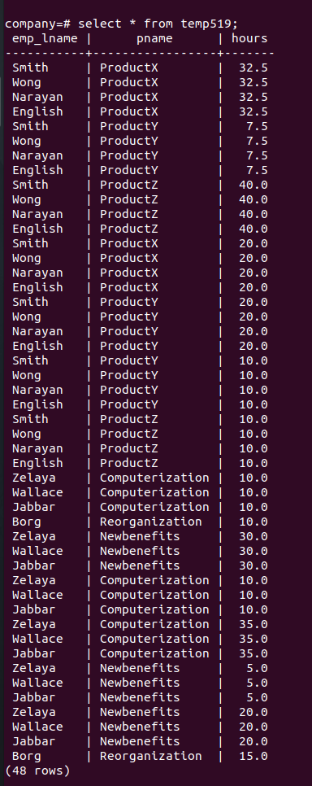

* Update project table where pnumber = 10 using update command:

Before updating:

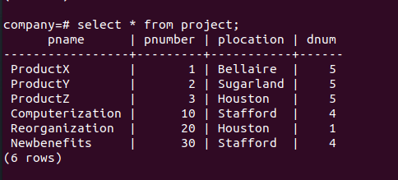

Updating the required entries by using the following query, we get the updated table as:

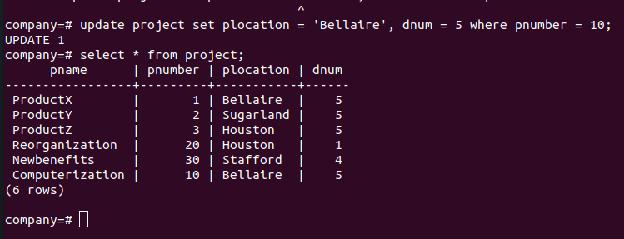

* Giving all the employees in 10% raise in Research dept using update command with select as subquery. We get the following updates:

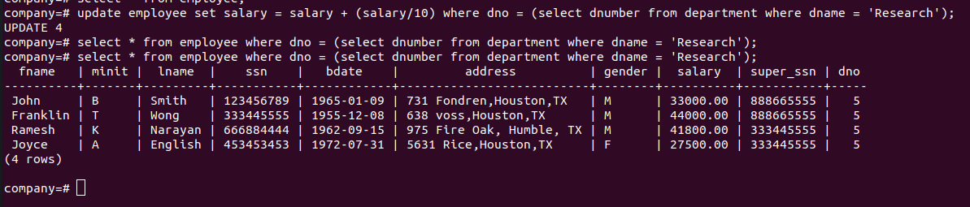

* Deleting entries in employee where lname = Brown

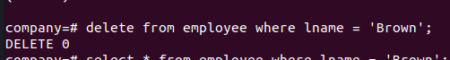

It is evident there are no such entries!

So I have demonstrated by deleting entries in employee where lname = Borg

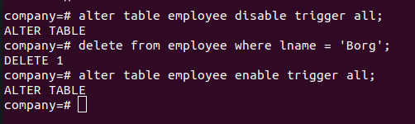

We will have referential integrity or fk constraint violation if we simply use delete command. So we can disable all triggers before deleting, delete the entries and enable it back. After deletion is successfull we can see that no entries exist with lname = Borg:

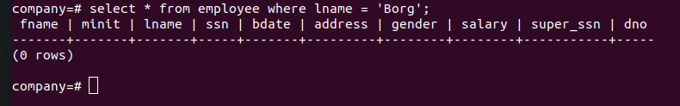

* Deleting all employees who don’t have dependents using select as subquery.

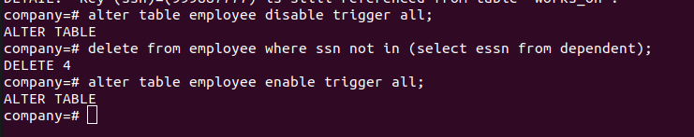

Again we will have referential integrity or fk constraint violation if we simply use delete command. So we can disable all triggers before deleting, delete the entries and enable it back.

1. **Transcations**

* We create a transaction with creating a table called cs519, inserting 4 tuples to it and ending it and hence commiting it. It is evident that after commiting, the changes are reflected in original db as well:

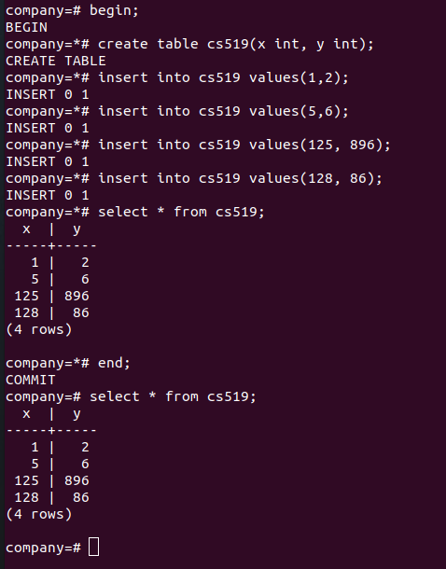

* Creating a transaction by creating a table called cs519_2, inserting 2 tuples to it and reverting all the changes. On reverting we see that neither create nor inserts are reflected. Even after ending the transaction and hence committing the changes, we see that the db doesn’t exist as we had reverted back and hence we got an error on using select command.

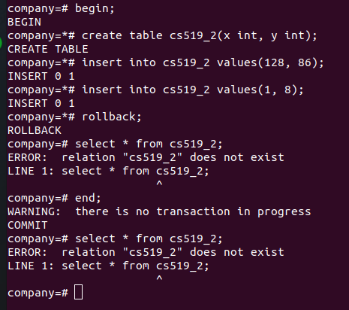

* Creating a transaction by creating a table called cs519_3 and inserting 2 tuples. Until this point a savepoint called “z” is created. After this, we add 2 more tuples to the table. Now on reverting to “z”, we can see only the 2 tuples inserted in the start. Even on ending the transaction and hence committing the transaction, we only see 2 tuples in the table instead of 4.

